Name:__________________ Date: __________ Period: ____

Cell Cycle Worksheet

MATCH THE PHASE WITH WHAT HAPPENS:
You CAN use them more than once

S G₁ G₂ Mitosis (M) Cytokinesis (C)

_______ Cells leave the cell cycle and stop dividing

______ Cell grows in size

______ Division of cytoplasm happens

______ Cell makes the molecules and organelles needed for cell division

______ Made up of telophase, anaphase, prophase, metaphase

_______ Cell parts are asssembled

_______ Cell makes a copy of its DNA

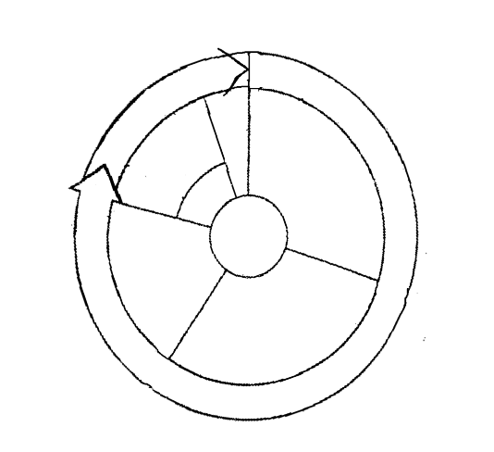
Label the diagram using the following words:

Synthesis
G1
G2
Mitosis
Cytokinesis
Interphase
M Phase

