Public Lands Postcards

As a member of Barajas’s Tourism Company, you have been given the task of creating several postcards illustrating public lands. You will be making 4 post cards

Choose 1: National Park
Choose 1: National Forest
Choose 1: Wilderness Area, National Wildlife Refuge, Land Trust
Choose 1: World Heritage Site OR Biosphere Reserve

For each post card you make, you must use a specific location. For example, you shouldn’t make a post card over generic “National Parks”, but rather “Yellowstone” or “The Grand Canyon”.

You must include the following for each post card:
Front: -A photo of the park (You must draw it yourself)
-The Name of the park
-Location of the park
-It should look like a post card on the front

Back: -The Type of public land this park represents
-A message on the post card (as if you are writing it to someone) that should include a very brief description of the history of the park & a description of the types of things going on at the park (logging, hunting, camping, hiking, mining, etc)
-A place for an address and stamp (these can be very small)

* MUST BE HAND MADE. NO PRINTS. NO EXCEPTIONS

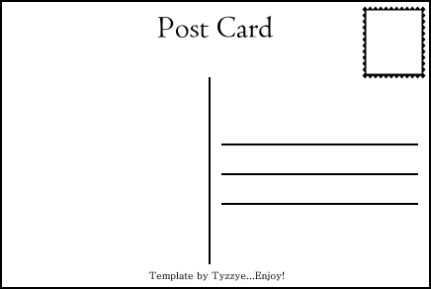
Example below:

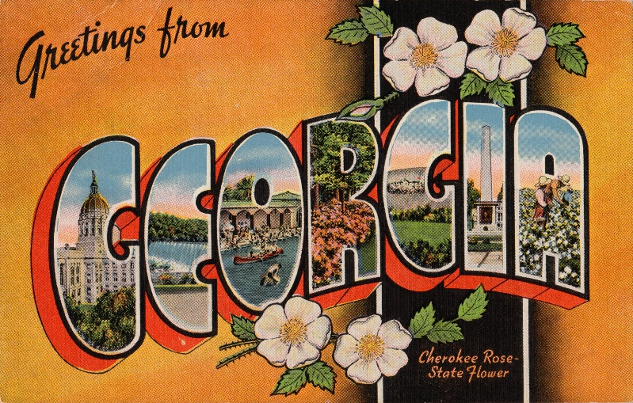
Front Back

