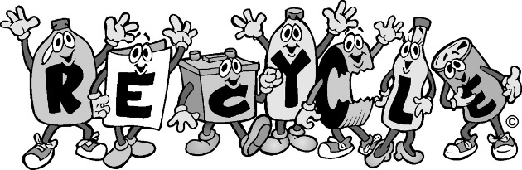
Upcycling Product Project

- DUE DATE: MAY 17th
- Converting trash to treasure! This new trend in recycling has proven to be both good for the environment (reduces waste from the landfill) and saves money. There is also a market for Upcycled products. Websites like ETSY – sell Upcycled goods and treasures created by resourceful people that are also concerned about waste. The products must serve a purpose or have a new use. Works of original art made from recycled materials or upcycles solely used for sculpture or wall decorations will not be accepted for this project.
- Must not be any larger than 1 meter square nor smaller than 3 cm square
- Must be made of at least 90% recycled or used items. You may purchase items like paint, glue, or tape to the construction of the product.
- Using websites like Pinterest for ideas and inspiration is certainly allowed – but a product must be your own creation. Credit for the idea must be given on the Project Protocol Sheet
- Ideas of recycled materials to use: plastic bottles, milk jugs, steel cans, aluminum cans, yarn, string, rope, ribbon, fabric scraps, colored paper scraps, greeting cards, buttons, popsicle sticks, pipe cleaners, glitter, paper towel rolls, wrapping paper, stickers, stamps, magazines, newspaper, scrap metal
- Your project must have a purpose/use and be able to last.
- I will be very picky on the products construction and purpose when grading. Remember this counts as a test grade.

Grading Rubric

 | Excellent | Good | Fair | Poor
Quality  of craftsmanship  10 pts | Project is constructed beautifully and shows close attention to specific details. Extremely high quality  8-10 | Project finished with most details, but shows flaws. Good quality  5-7 | Project finished, but somewhat messy and pieces not completely attached.  3-4 | Project finished with no attention to details. Looks like it was quickly thrown together. Will not last long.  0-2
Effort  10 pts | Project is finished with maximum effort and went above and beyond the requirements. Shows a lot of time was spent to create.  8-10 | Project finished with hard work and effort, but is lacking important details and does not go above and beyond. Shows a lot of time was spent to create.  5-7 | Project finished with minimum effort and minimum amount of time  3-4 | Project is unfinished or project completed but shows very little time or effort.  0-2
Creativity  10 pts | Object is UNIQUELY created – no part of the system has been copied from other sources  8-10 | Object is relatively unique using parts of other systems in creatively different ways  5-7 | Object is a modification of a former design  3-4 | Object is a COPY of a former design  0-2
Use of recyclable  or reused goods  10 pts | 100% recyclable or reused material  8-10 | 80% recyclable or reused material  5-7 | 60% recyclable or reused material  3-4 | Less than 50% recyclable or reused material  0-2
Attitude  10 pts | Shows great interest in creating project.  8-10 | Shows interest in creating project  5-7 | Shows little interest in creating project  3-4 | Shows little to no interest. Comes in with bad attitude.  0-2
Total (50 points)

