APES SOIL LABS Names: _________________________________________________________________

Introduction:
Soil is a thin covering over most land that is a complex mixture of eroded rock, mineral nutrients, decaying organic matter, water, air, and billions of living organisms, most of them microscopic decomposers. Soil is the base of life on land. Producers that supply food for us and other consumers get the nutrients they need from soil and water. Soil helps cleanse water percolating downward through it. Soil also helps decompose and recycle biodegradable wastes and is a major component of the earth’s water recycling and water storage processes. In addition, it helps control the earth’s climate by removing carbon dioxide from the atmosphere and storing it as carbon compounds. Since the beginning of agriculture, human activities have accelerated natural soil erosion, which can convert this renewable resource into a nonrenewable resource.

Soils vary in the size of the particles they contain, the amount of space between these particles, and how rapidly water flows through them. Soils are mixtures of particles of three different sizes: very small (>0.002mm) clay particles, medium size (0.002-0.05mm) silt particles, and larger (0.05-2mm) sand particles. The relative amounts of the different sizes and types of these mineral particles determine soil texture. A loam topsoil, a relatively even mix of the three particles, is best suited for plant growth. A simple technique known as ribboning can help distinguish the soil texture through the use of a dichotomous key. A more precise measure of soil texture can be determined through separation of the soil types and use of a Soil Texture Triangle.

Day 1 Instructions: Nutrient Test/Soil Texture
Activity 1
- Fill your collection container with soil from you yard. Remove any obvious plant matter.
- Using a soil sieve, sift your collected soil to remove any rocks or macroscopic organisms from the sample. Large sifted items can be placed outside. Return the sifted soil to your collection container.
- Using a graduated cylinder, measure 25 ml of soil and place it in your collection container.
- Add 175ml water to the soil and mix well. Cover with your hand when mixing.
- Cover your container with wax paper and place a rubber band around it to seal it.
- Label your container. Include group name & the words “nutrient test”.
- Place the container in the area designated by your teacher; we will be using this later in the week.
Activity 2
- Using the graduated container (green top), measure 25 ml of soil.
- With the soil still in the graduated container, add water to the 75ml line.
- Add 2 drops of dawn dish soap to the water/soil mixture.
- Covering the top of the graduated container with the green top, mix the contents by shaking hard for several minutes.
- Label the graduated container. Include group name & the words “soil texture”.
- Place the graduated container with your beaker, in the area designated by the instructor.

- Save your remaining soil for tomorrow. Label your collection container with your period & group name and store with your other items.
- Return all remaining materials, and clean your desk of any soil particles.

Day 2 Instructions: Soil Nutrients and Soil Texture Triangle Set-Up
Activity 1
Soil Nutrients Testing – In order for producers to survive on land, they must receive the appropriate nutrients from the soil, water and air around them. Carbon, hydrogen and oxygen are supplied by water and air, so the remaining essential nutrients must come from the soil. The primary nutrients required by producers are Nitrogen (N), Phosphorus (P), and Potassium (K). Secondary nutrients include Sulfur (S), Calcium (Ca), and Magnesium (Mg). Additionally, several other micronutrients are necessary for healthy plant growth. The presence of these nutrients in addition to pH (optimal between 5.5-7.5), salinity, and electrical conductivity make up chemical indicators of soil quality. Soil quality is also determined by looking at physical properties (structure, depth, infiltration, water-holding capacity), biological properties (microbial activity and biomass), and presence of organic matter.
  - Retrieve your container labeled nutrient test. Be careful not to shake up the settled soil as you transport the soil to your table.
  - Following the instructions provided with the RapiTest Soil Nutrients Kit to test your soil for nitrogen, phosphorus, and potassium.
    - Remove water using a plastic pipette to avoid disrupting the settled soil. DO NOT BLOW AIR INTO THE BEAKER WITH YOUR PIPETTE!!!
    - Use Natural Light (outside) to compare color change for nutrient level. Go to the window in the hall.
  - Use the water remaining in the beaker to test for soil pH, using the pH paper provided.
  - Record all data in the table below.
  - Dump water and soil remaining in the beaker outside. Clean the beaker and all soil test kits in the sink.

Soil Properties: | Potassium (K-Test) | Nitrogen (N-Test) | Phosphorus (P-test) | pH
Levels:

Laboratory Questions:
1. What causes soil to become acidic?

2. Why is soil acidity associated with nutrient depletion?

3. What are the causes of nutrient depletion in soil?

4. What can be done nutrient depletion in soil?

5. Was your soil most deficient in N, P, or K?

Activity 2
Soil Texture Triangle – Using the soil texture triangle, scientists have created classes which break the distribution of particle sizes (soil textures) into 12 categories: clay, sandy clay, silty clay, sandy clay loam, clay loam, silty clay loam, sand, loamy sand, sandy loam, loam, silt loam, and silt. The soil texture is one of the tools that soil scientists use to visualize and understand the meaning of soil texture names. The textural triangle is a diagram which shows how each of these 12 textures is classified based on the percent of sand, silt and clay in each. Note: these percentages are based on the USDA definition of sand and silt only.

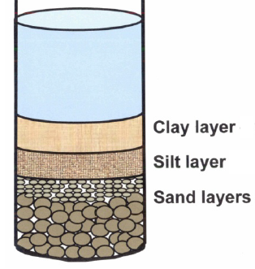
  - Retrieve your graduated cylinder labeled “soil texture”. BE EXTREMELY CAREFUL not to shake up the settled soil as you transport the soil to your table.

  - Record the total volume (mL) of the settled soil layers: ________

  - Record the volume (mL) of each of the settled layers:
    - Volume of Sand Layer: ___________
    - Volume of Silt Layer: ___________
    - Volume of Clay Layer: ___________

  - Calculate the percentage of sand, silt and clay present in your soil sample (show your work):
    - Clay volume/total thickness x 100 = % clay

    - Silt volume/total volume x 100 = % silt

    - Sand volume/total volume x100 = %sand

  - Use the Soil Texture Triangle below to determine the quantitative soil texture of your soil sample.

My Soil Texture: _____ % Sand + ______% Silt +______% Clay = ___________________________ soil texture

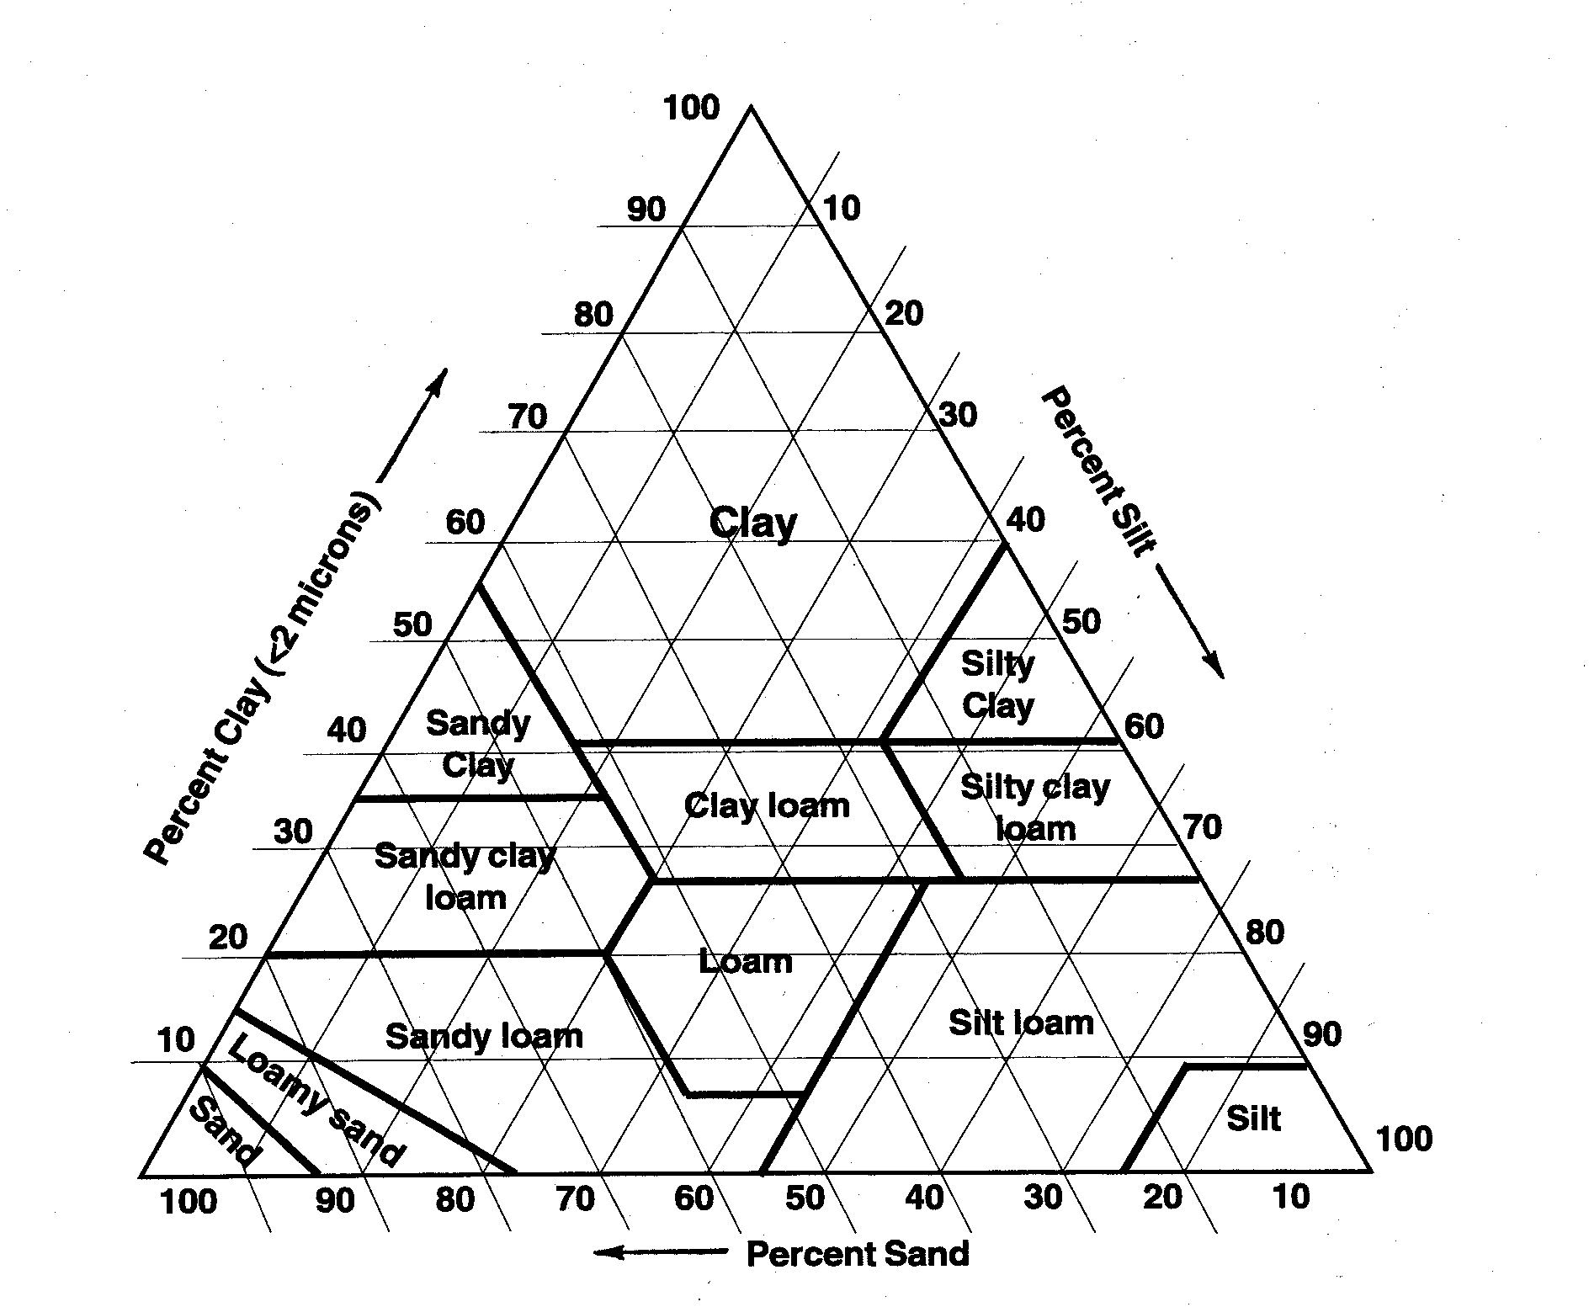

  - Clean all lab materials, return them to their proper place as indicated by your instructor.

